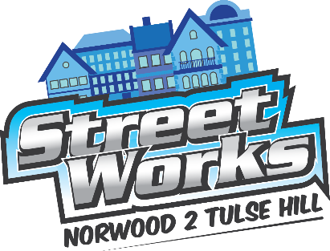 | Steering Group  Tuesday 15 December 2015 (3.30pm)  The Old Library, 14-16 Knights Hill, SE27 0HY  Agenda

Members:
Norwood Forum: Noshir Patel (NP) (Chair) and Jan Ware (JW)
Tulse Hill Forum: Grace English (GE) / Margaret Pierre-Jarrett (MPJ) and
Erica Tate (Vice-Chair) (ET)
Lambeth Councillors: Mary Atkins (MA), Anna Birley (ABi) and Jackie Meldrum (JM)
Lambeth Council officers: Abu Barkatoolah (ABa), Sarah Coyte (SC) and Saleem Patel (SP)
Landolt & Brown: Adam Brown (ABr)
Transport for London (TfL): Simon Mouncey (SM)

Support officers:
Lambeth Council: Andrea Stewart (AS)
Community: Tim Stephens (Admin.) (TS) and Georgina Wilson (Comms. & Outreach) (GW)
Also invited:
Lambeth Councillors: Jenny Brathwaite (Cabinet Member for Environment & Sustainability) (JB)
Lambeth Council officer: Victoria Dioh (VD)
Local resident and Sustrans: Bryn Lockwood (BL)
Local resident and Norwood Forum Treasurer: Sunil de Sayrah (SdS)

 | Agenda item | Lead | Timings
 | Any necessary introductions and apologies
 | Core agenda items
 | Co-design workshop #4 (8 December 2015): feedback | ABr & ABa | 3:30-4:10pm
 | Comms: housing estate residents | ABa | 4:10-4:40pm

 | Agenda item | Lead | Timings
 | Other agenda items
 | Notes/actions (01.12.15) (attached)  Notes:  - Approved notes will be uploaded to Trello (TS) and public website (GW)  - Action points not covered by agenda items are in bold. | NP | 4:40-4:50pm
 | Finance: funding for Norwood Forum | VD & SdS | 4:50-4:55pm
 | Retail survey: update | SP | 4:55-5:05pm
 | Programme | ABa | 5:05-5:15pm
 | AOB  Including:  - Confirm all future meetings to be held 3:30-5:30pm |  | 5:15-5:20pm
Date of next meeting:
- Tuesday 12 January 2016

Planned break

Workshop:

 | Tulse Hill Gyratory: development of vision workshop | ABr | 5:30-7:00pm

10 December 2015

Tim Stephens
Streetworks Administrator
timjstephens99@gmail.com

_________________________

